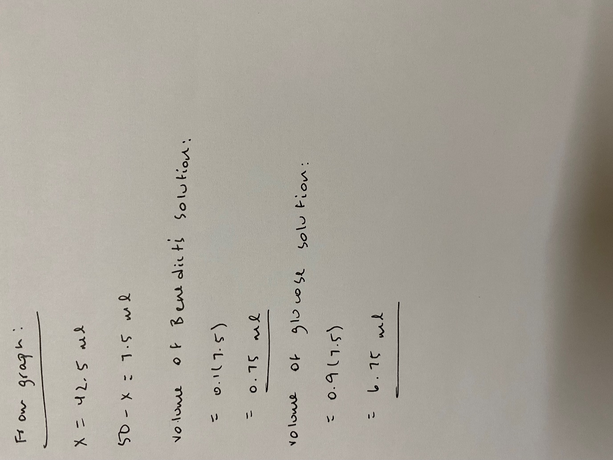**Calculations from Graph:**

**Graph on Next Page:**

